| **Architecture** | **Test Accuracy** | graph |  |
| --- | --- | --- | --- |
| CONV | 69.7% |  |  |
| LSTM | 35% |  |  |
| GRU | 27.7% |  |  |
| CONV+GRU | 73% |  |  |
| CONV+LSTM | 72.7% |  |  |

# Conv

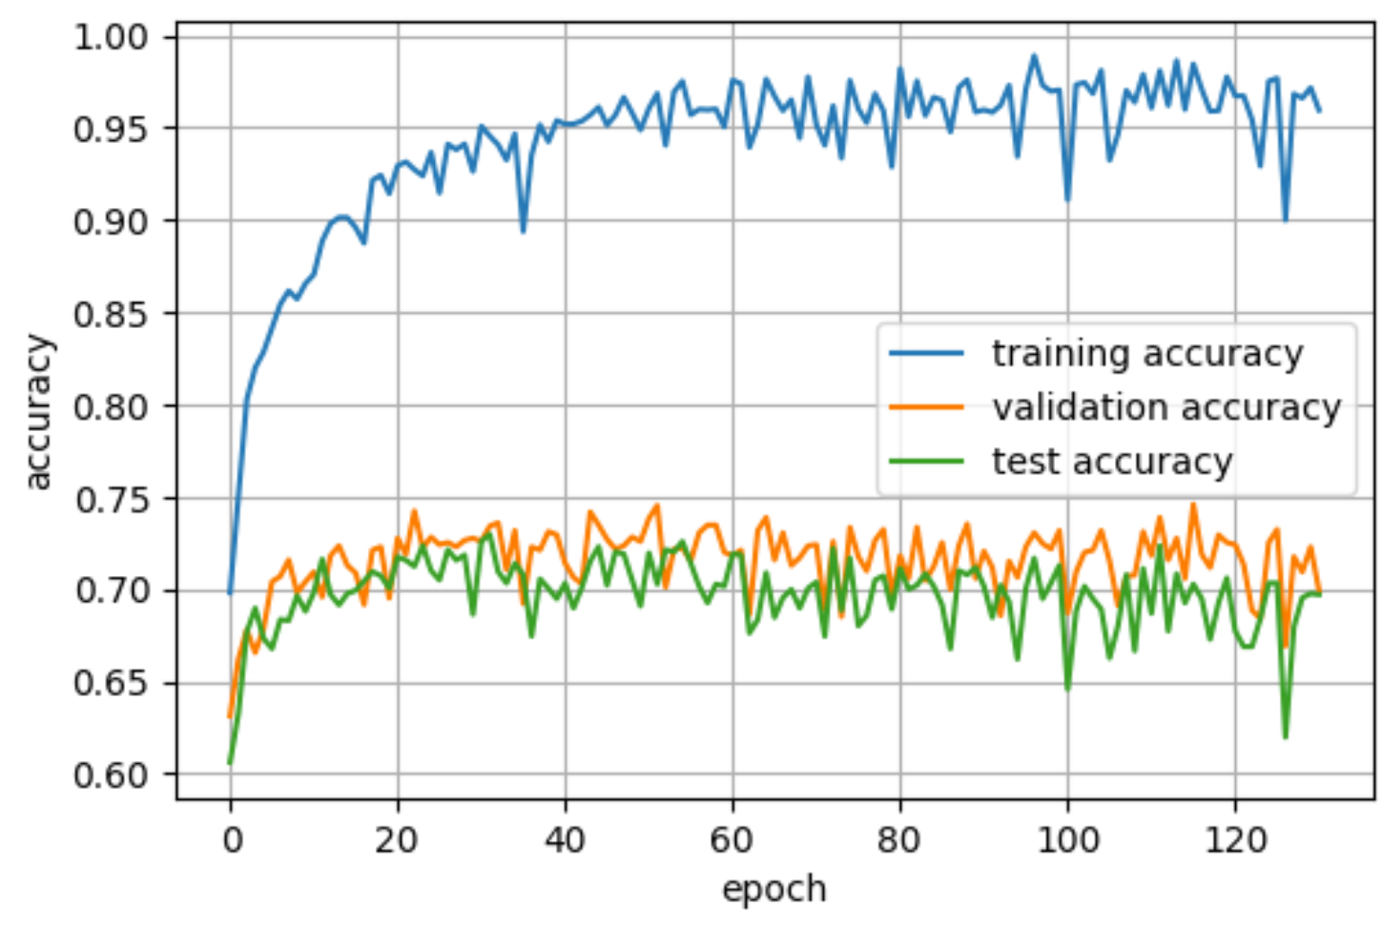

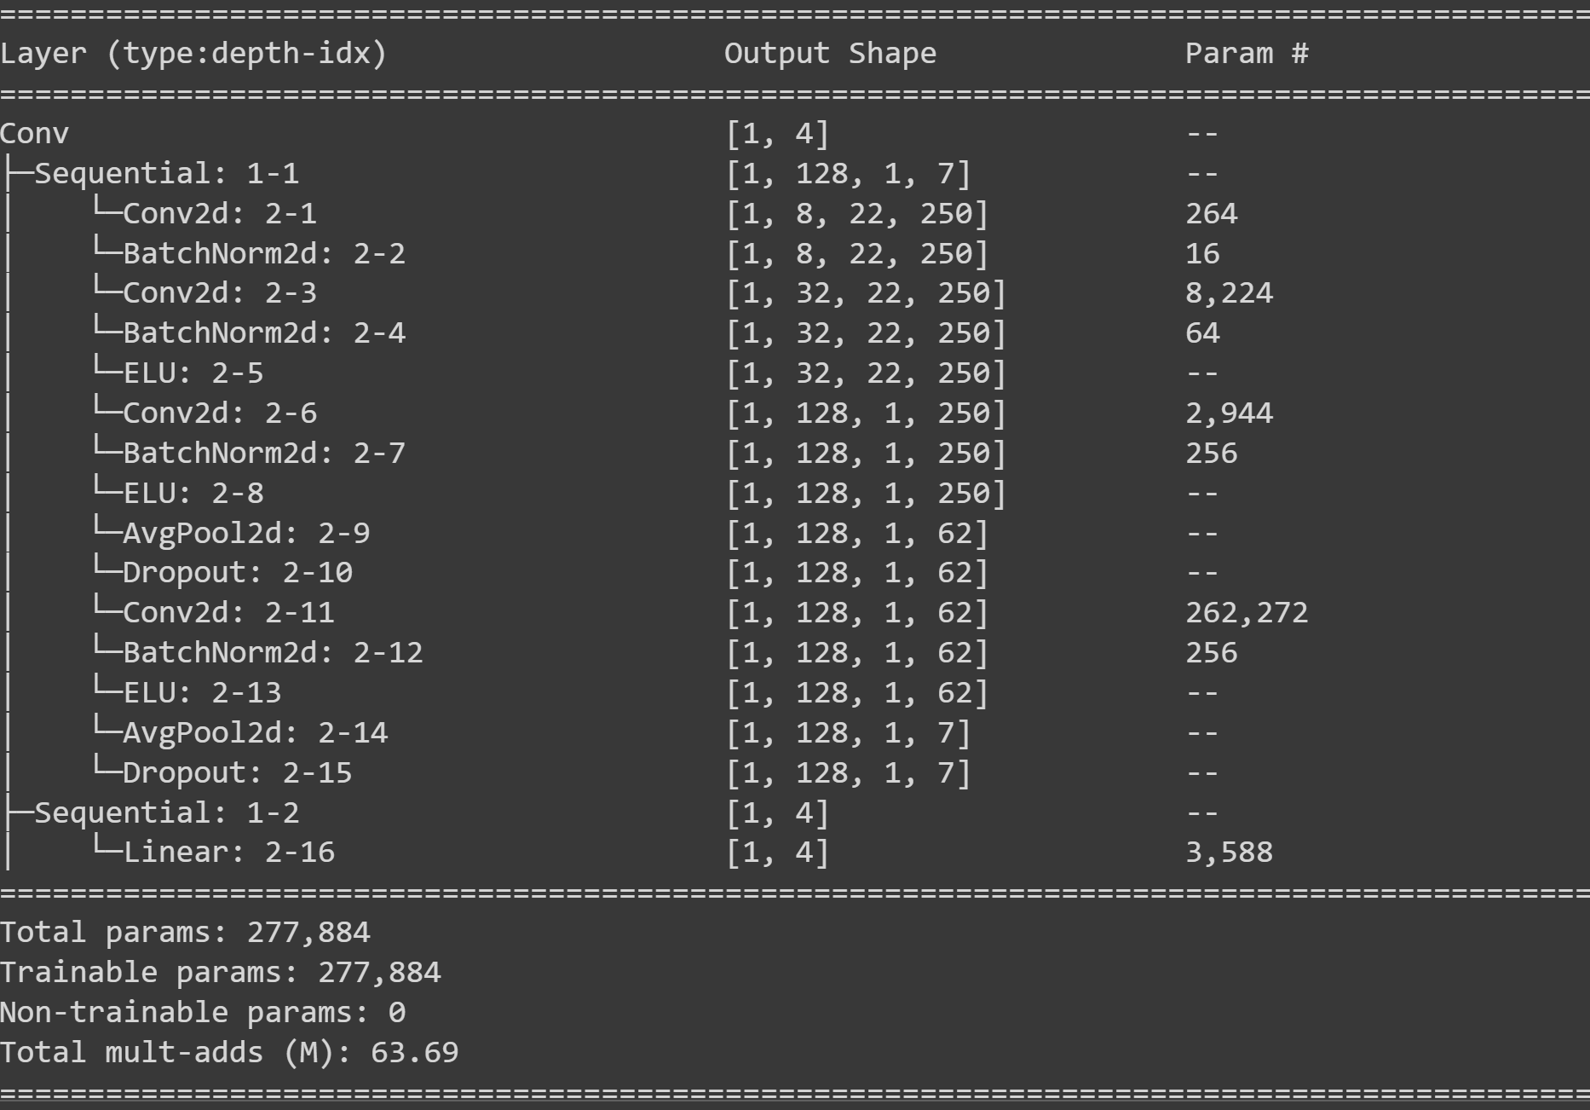

# LSTM

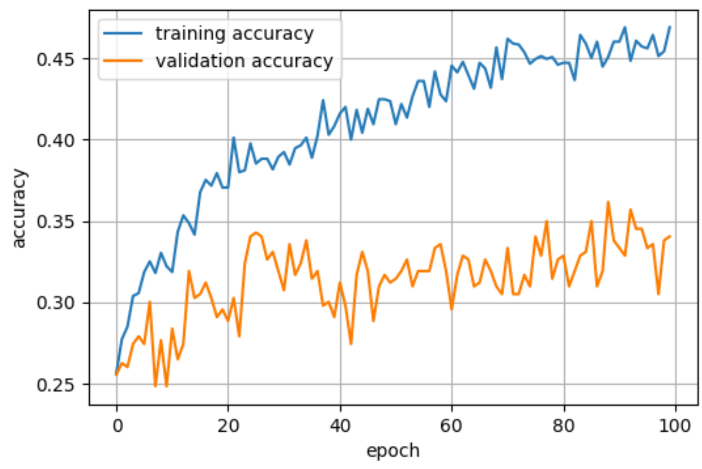

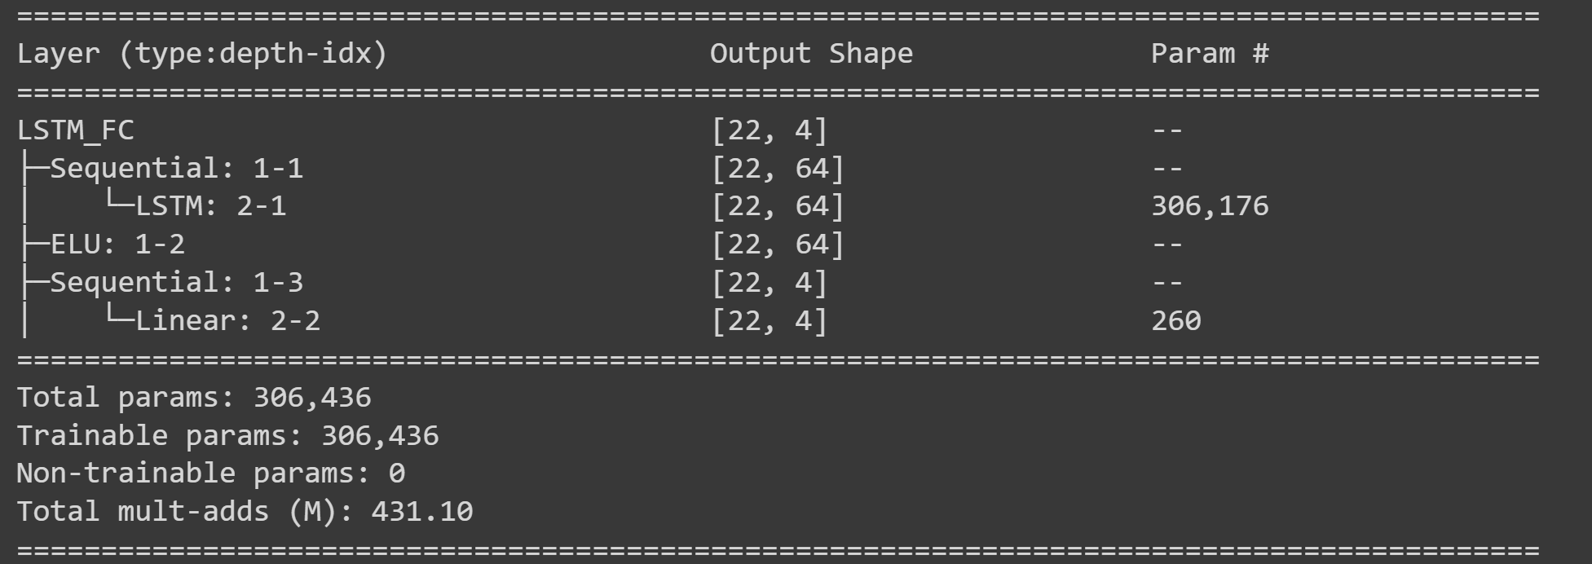

# GRU

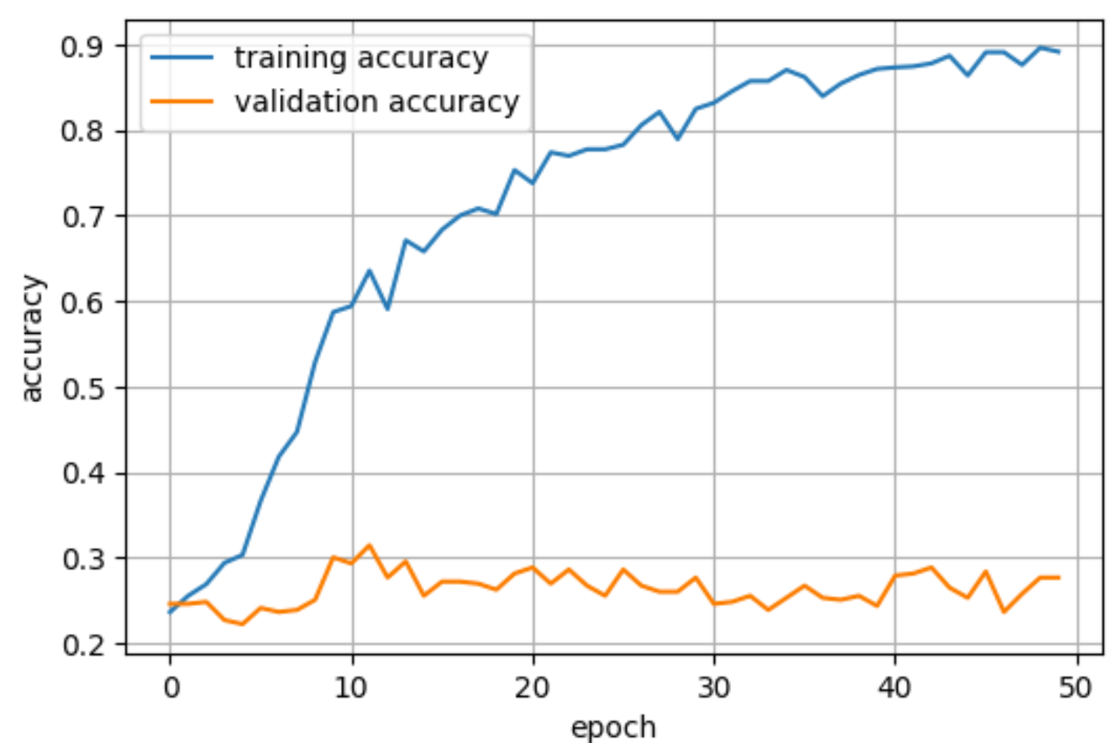

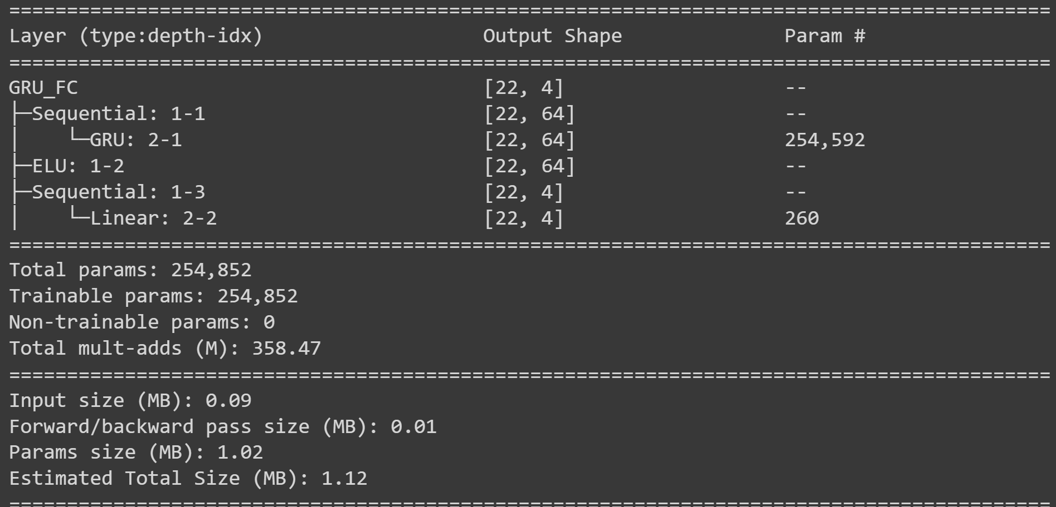

# CONVLSTM

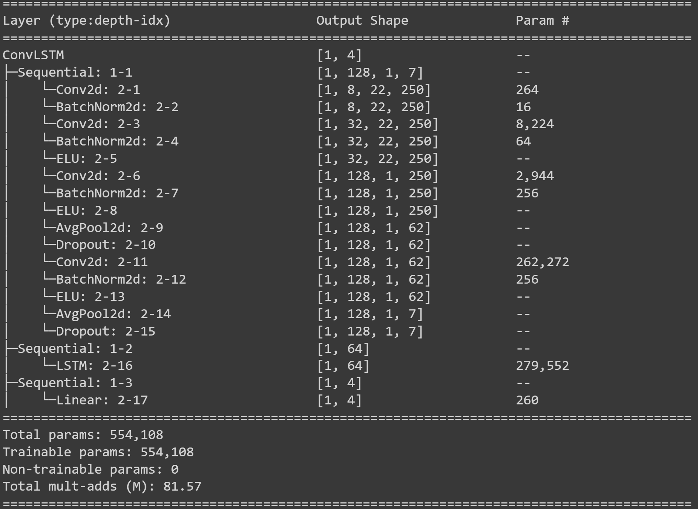

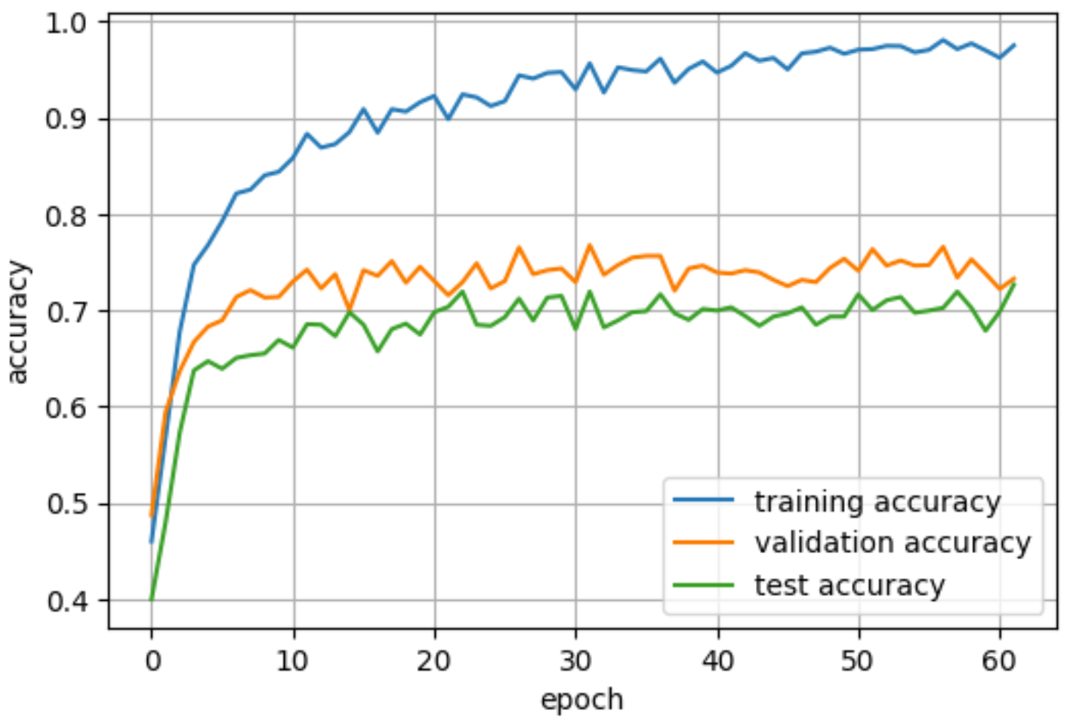

# CONVGRU

